Civil war in Georgia

UNSC Resolution: | 971
Date of adoption: | 12-Jan-1995
Operative paragraph: | 4
Demand number: | 971.04.11

David Siroky

Wording of demand
reach substantive progress in negotiations aimed at achieving a comprehensive political settlement of the conflict, including on the political status of Abkhazia, respecting fully the sovereignty and territorial integrity of the Republic of Georgia, under the auspices of the UN and with the assistance of the Russian Federation as facilitator and with participation of representatives of the OSCE

List of addressees of the demand
Government of Georgia, Abkhazia

Short-term compliance

Description of the addressee(s)’ conduct

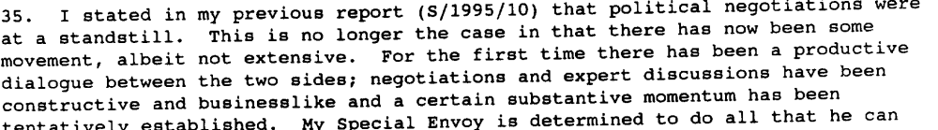s/1995/181

- 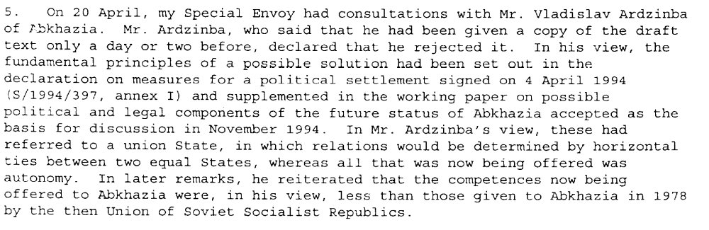s/1995/342

- 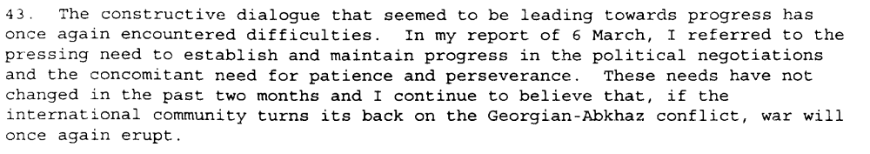s/1995/342

Assessment

Short-term compliance
No or marginal compliance (1) | Medium low compliance (2) | Medium high compliance (3) | Full or almost full compliance (4)

Considerations underlying the assessment

Medium-term compliance

Description of the addressee(s)’ conduct

s/1995/181

- s/1995/342

- s/1995/342
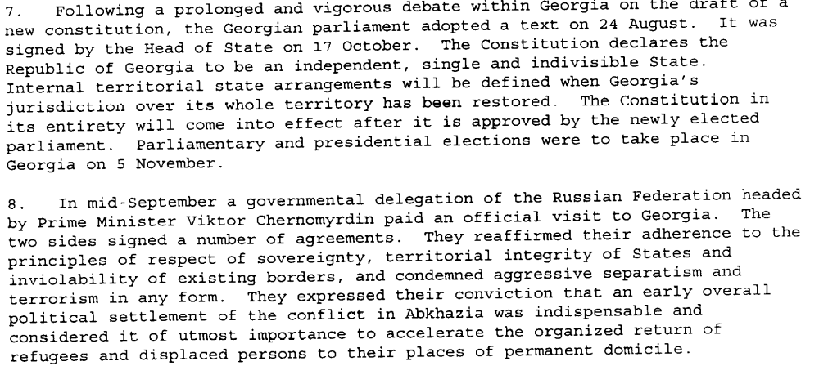S/1995/937

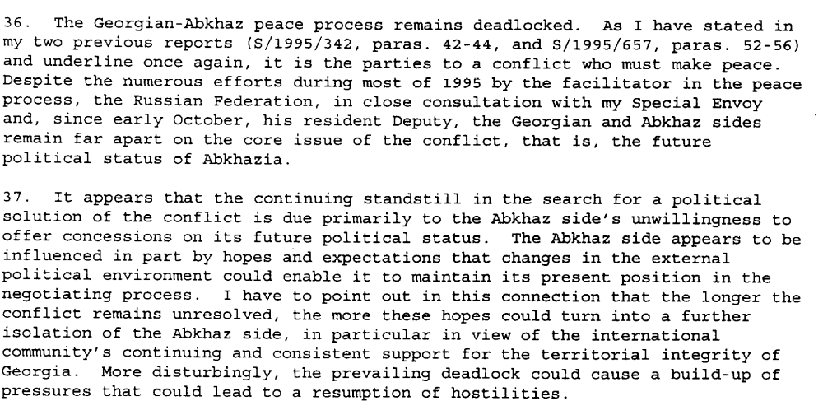S/1995/937

Assessment

Medium-term compliance
No or marginal compliance (1) | Medium low compliance (2) | Medium high compliance (3) | Full or almost full compliance (4)

Considerations underlying the assessment

Depth of demand

Assessment

Level of depth of demand
Low depth of demand (1) | Medium depth of demand (2) | High depth of demand (3)

Considerations underlying the assessment

Level of confidence about coding decisions
Level of confidence about coding decision
Extremely high | High | Moderate

Comments to IPI (if any)

Civil war in Georgia

UNSC Resolution: | 971
Date of adoption: | 12 July 1995
Operative paragraph: | 5
Demand number: | 971.0511

David Siroky

Wording of demand
comply with their commitments with regard to the return of refugees and displaced persons, as undertaken in the Quadripartite Agreement

List of addressees of the demand
Government of Georgia, Abkhazia

Short-term compliance

Description of the addressee(s)’ conduct
From Sochi, my Specal Envoy went to Gagra in Abkhazia for a meeting wth Mr. Vladislav Ardzinba, the Abkhaz leader. After a review of the current situation in Abkhazia, including the serous effects of recent heavy rains, discussion turned to the draft protocol. Regarding the return of refugees, Mr. Ardzinba wished to work with the arrangement already set up under the quadripartite agreement. Moreover, he did not accept that the collective peace-keeping forces of the CIS should take an active part n providing security for returnees. In his view, there could be no police functions for anyone other than the Abkhaz authorties. On concluding the discussions, Mr. Ardzinba expressed his wish that ways be found to continue the negotiation process. (S-G’s Report, August, 1995)

On 16 July, my Specal Envoy proceeded to Tbiilisi to meet wth Mr. Eduard Shevardnadze, Head of State of the Republic of Georgia. Mr. Shevardnadze expressed his deep unhappiness at the continued lack of real progress. Despite 10 resolution of the Security Council, there had been no tangible results to date. (S-G’s Report, August 1995)

Although a certain amount of progress has been made, it has not been sufficient to resolve the pressing problem of the return of refugees and displaced persons. (S-G’s Report, August 1995)

Assessment

Short-term compliance
No or marginal compliance (1) | Medium low compliance (2) | Medium high compliance (3) | Full or almost full compliance (4)

Considerations underlying the assessment

Medium-term compliance

Description of the addressee(s)’ conduct
In spite of continuous efforts aimed at achieving a comprehensive political settlement of the Georgian Abkhaz conflict, no significant progress has yet been achieved. The key unresolved issues remain the future political status of Abkhazia and the return of refugee and displaced persons. (S-G’s Report, Oct 1996)

The UNHCR believes that humanitarian assistance should be given to those who are displaced…Though hampered by the laying of mines, UNHCR has continued to rehabilitate schools in the Gali region for the benefit of spontaneous returnees. (S-G’s Report, Oct 1996)

Key issues of the peace process, such as the future political status of Abkhazia and the return of refugees and displaced persons, remain unresolved. However, in discussions with the Special Envoy, both sides have recently reaffirmed their desire for a political solution. (S-G’s Report, February 1997)

The absence of progress in the settlement of the Georgian/Abkhaz conflict, including the problem of the refugees and internally displaced persons, has created widespread dissatisfaction among the Georgian population and the country’s leadership is being increasingly urged to take decisive action. (S-G’s Report, April 1997)

Assessment

Medium-term compliance
No or marginal compliance (1) | Medium low compliance (2) | Medium high compliance (3) | Full or almost full compliance (4)

Considerations underlying the assessment

Depth of demand

Assessment

Level of depth of demand
Low depth of demand (1) | Medium depth of demand (2) | High depth of demand (3)

Considerations underlying the assessment

Level of confidence about coding decisions

Level of confidence about coding decision
Extremely high | High | Moderate

Comments to IPI (if any)

Civil war in Georgia

UNSC Resolution: | 971
Date of adoption: | 12 July 1995
Operative paragraph: | 5
Demand number: | 971.0512

David Siroky

Wording of demand
accelerate the process [related to return of refugees and internally displaced persons] significantly

List of addressees of the demand
Abkhazia

Short-term compliance

Description of the addressee(s)’ conduct

On 16 July, my Specal Envoy proceeded to Tbiilisi to meet wth Mr. Eduard Shevardnadze, Head of State of the Republic of Georgia. Mr. Shevardnadze expressed his deep unhappiness at the continued lack of real progress. Despite 10 resolution of the Security Council, there had been no tangible results to date. (S-G’s Report, August 1995)

Although a certain amount of progress has been made, it has not been sufficient to resolve the pressing problem of the return of refugees and displaced persons. (S-G’s Report, August 1995)

Assessment

Short-term compliance
No or marginal compliance (1) | Medium low compliance (2) | Medium high compliance (3) | Full or almost full compliance (4)

Considerations underlying the assessment

Medium-term compliance

Description of the addressee(s)’ conduct

In spite of continuous efforts aimed at achieving a comprehensive political settlement of the Georgian Abkhaz conflict, no significant progress has yet been achieved. The key unresolved issues remain the future political status of Abkhazia and the return of refugee and displaced persons. (S-G’s Report, Oct 1996)

The UNHCR believes that humanitarian assistance should be given to those who are displaced…Though hampered by the laying of mines, UNHCR has continued to rehabilitate schools in the Gali region for the benefit of spontaneous returnees. (S-G’s Report, Oct 1996)

Key issues of the peace process, such as the future political status of Abkhazia and the return of refugees and displaced persons, remain unresolved. However, in discussions with the Special Envoy, both sides have recently reaffirmed their desire for a political solution. (S-G’s Report, February 1997)

The absence of progress in the settlement of the Georgian/Abkhaz conflict, including the problem of the refugees and internally displaced persons, has created widespread dissatisfaction among the Georgian population and the country’s leadership is being increasingly urged to take decisive action. (S-G’s Report, April 1997)

Assessment

Medium-term compliance
No or marginal compliance (1) | Medium low compliance (2) | Medium high compliance (3) | Full or almost full compliance (4)

Considerations underlying the assessment

Depth of demand

Assessment

Level of depth of demand
Low depth of demand (1) | Medium depth of demand (2) | High depth of demand (3)

Considerations underlying the assessment

Level of confidence about coding decisions

Level of confidence about coding decision
Extremely high | High | Moderate

Comments to IPI (if any)

